NORTHWIND SALES DASHBOARD

Using Microsoft Power BI

Project Report
Submitted By:
Name: Swarnalakshmi J
Tool Used: Microsoft Power BI Desktop

1. Introduction
This report documents the Power BI dashboard built on the Northwind sales dataset, which covers customers, employees, products, categories, orders and shippers. The report has five pages: Sales Overview, Product and Customer Analysis, Interactive Sales Dashboard, a Category Tooltip page and a Category Details drill-through page. Together they let a user understand orders, quantities sold, sales and freight without going through the raw tables.

Objectives
- To summarise orders, customers, quantity sold and freight through KPI cards.
- To track order trends over time.
- To compare sales across product categories.
- To compare employee performance by number of orders.
- To analyse products and customers by country.
- To make the dashboard interactive through slicers, a tooltip and drill-through.

2. Dataset Overview
The data model contains 7 related tables. Orders and Order_details hold the transactional records, while the other tables describe customers, employees, products, categories and shippers.
Table | Description
Orders | Order-level records including order date and freight.
Order_details | Line items of each order: products, quantity and sales.
Products | Product names and quantity per unit.
Categories | Product categories (CategoryName).
Customers | Customer records including country.
Employees | Employees who handled the orders (EmployeeName).
Shippers | Shipping companies used for delivering orders.

3. Measures Created
Six DAX measures were created and are used across the dashboard:
Measure | Table | Used in
TOTAL ORDERS | Orders | KPI cards, line chart, employee bar chart, tooltip, details page
TOTAL QUANTITY SOLD | Order_details | KPI cards, product tables, tooltip, details page
TOTAL SALES | Order_details | Category column chart, product tables, tooltip, details page
TOTAL FREIGHT | Orders | KPI cards
AVERAGE FREIGHT | Orders | KPI card (Sales Overview)
NUMBER OF CUSTOMERS | Customers | KPI cards, country bar chart

4. Dashboard Design
The report contains five pages:
Page | Purpose
Sales Overview | One-page summary with KPI cards, order trend, sales by category and orders by employee.
Product and Customer Analysis | Product-level table and customers by country.
Interactive Sales Dashboard | Main dashboard with slicers for year, region and category.
Category Tooltip | Custom tooltip showing sales, quantity and orders for a category.
Category Details | Drill-through page for a selected category, with a back button.

Page 1: Sales Overview
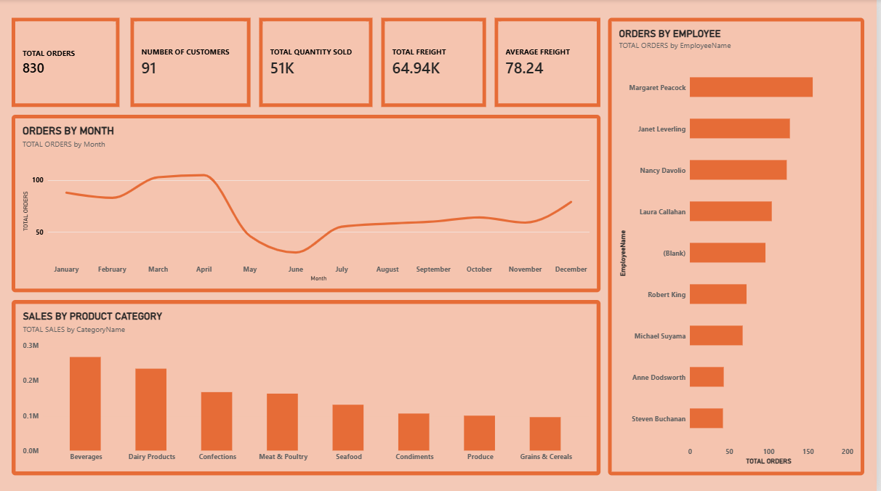
Figure: Sales Overview page

KPI Cards
Five cards show the most important figures at a glance:
Card | Value | Meaning
Total Orders | 830 | Number of orders placed
Number of Customers | 91 | Customers in the dataset
Total Quantity Sold | 51K | Units sold across all orders
Total Freight | 64.94K | Total shipping cost
Average Freight | 78.24 | Average shipping cost per order

The dataset records 830 orders from 91 customers, with a total sales value of 1.27M. These cards provide important information immediately without requiring the user to study the complete dashboard.
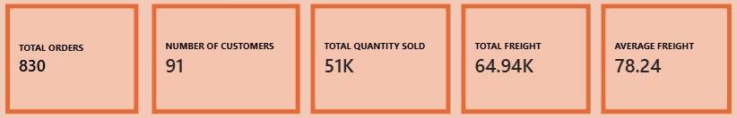
Figure: KPI cards

Page 3: Interactive Sales Dashboard
The main dashboard places the orders trend, sales by category and orders by employee beside a panel of slicers and summary cards, so every visual updates together when a filter is applied.
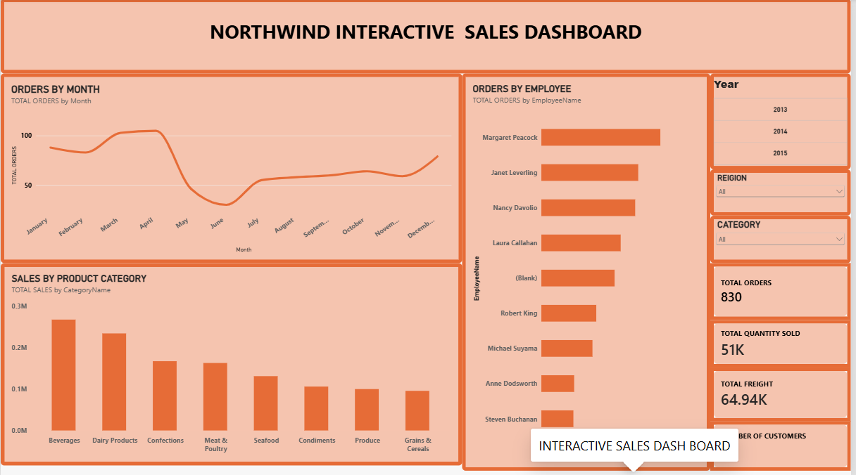
Figure: Interactive Sales Dashboard

5. Visualizations Used

->Orders Trend Over Time
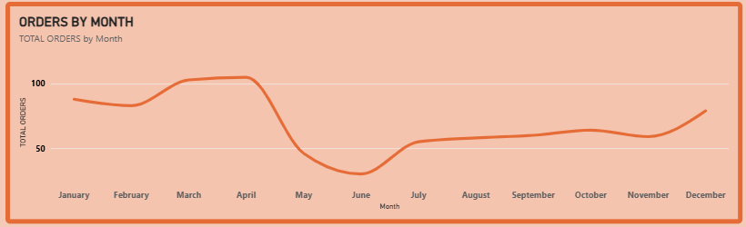
Figure: Orders by Month
A Line Chart is used to display the total number of orders month by month.
This visualization helps identify changes in order volume over time. Orders are highest in March and April, at slightly above 100 orders a month. They then fall sharply in May and reach their lowest point in June, at about 30 orders. After June, orders recover slowly and rise to about 80 by December.
Purpose:
- To identify order trends.
- To observe seasonal fluctuations.
- To identify periods of high and low activity.

->Sales by Category
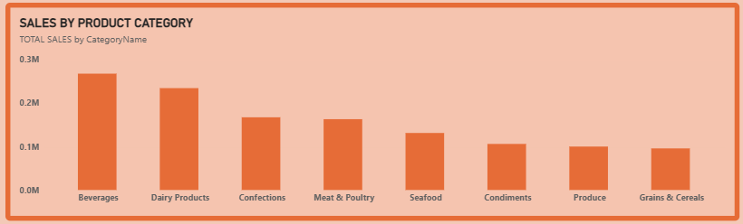
Figure: Sales by Product Category
A Clustered Column Chart is used to compare the total sales of each product category.
This makes it easier to identify the categories that generate the most revenue and those with relatively lower sales. Beverages is the top category with sales of about 0.27M, followed by Dairy Products at about 0.23M. Grains & Cereals has the lowest sales, at just under 0.1M.
Purpose:
- To compare category performance.
- To identify top-selling categories.
- To identify categories requiring attention.

->Orders by Employee
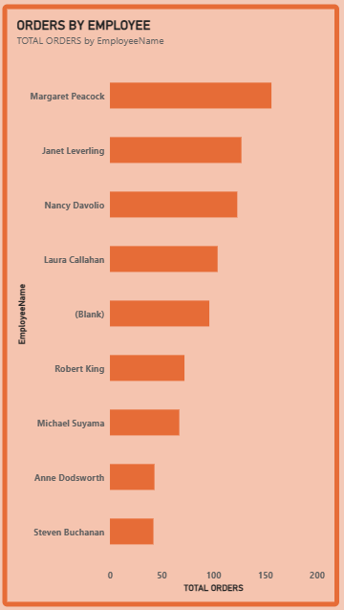
Figure: Orders by Employee
A Clustered Bar Chart is used to compare the total number of orders handled by each employee.
Margaret Peacock handled the most orders (about 155), followed by Janet Leverling and Nancy Davolio. Steven Buchanan handled the fewest (about 40). A group of orders has no employee name and appears as (Blank).
Purpose:
- To compare employee performance.
- To identify top-performing employees.
- To understand how the workload is distributed.

->Customers by Country
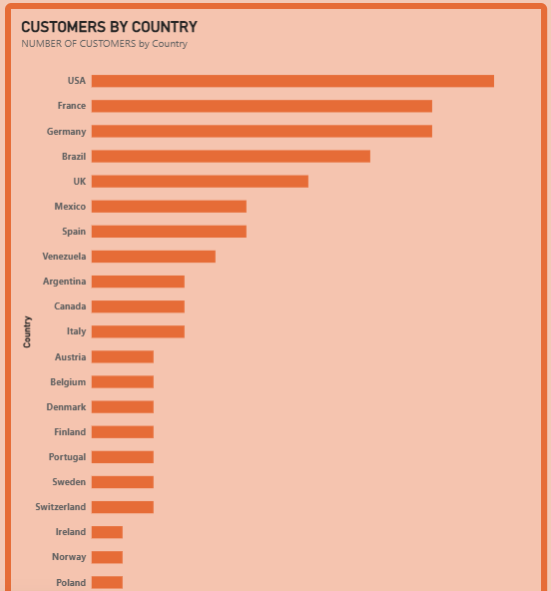
Figure: Customers by Country
A Clustered Bar Chart is used to show the number of customers in each country.
The USA has the most customers (13), followed by France and Germany with 11 each, Brazil with 9 and the UK with 7. Many smaller markets have only 1 to 3 customers.
Purpose:
- To understand the geographic spread of customers.
- To identify key markets.

->Product Sales Table
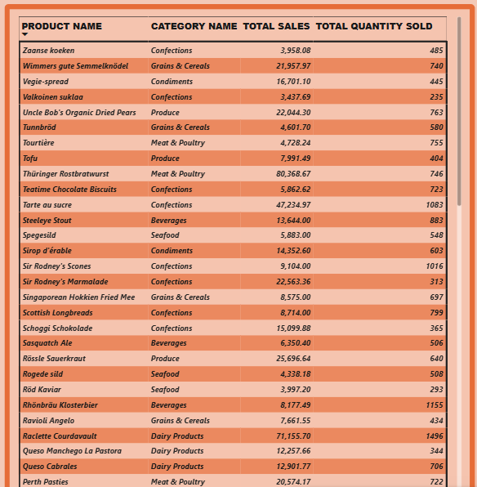
Figure: Product table
A Table lists each product with its category, total sales and total quantity sold. The table total shows overall sales of about 1.27M. Among the products visible in the table, Thüringer Rostbratwurst (about 80.4K) and Raclette Courdavault (about 71.2K) have the highest sales.
Purpose:
- To show exact product-level figures.
- To compare sales and quantity together for each product.
- To identify best-selling and slow-moving products.

->Category Tooltip
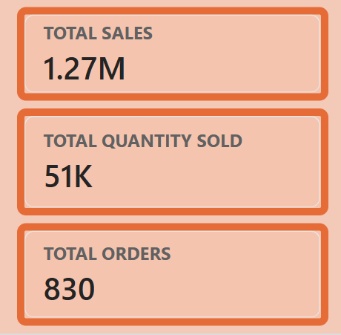
Figure: Category tooltip cards
A custom tooltip page shows total sales (1.27M with no filter), total quantity sold (51K) and total orders (830) when the user hovers over a category in the sales chart. This gives extra detail without adding more visuals to the main page.

->Category Details (Drill-through)
A drill-through page shows detailed figures for one selected category: total sales, total quantity sold, total orders and a product table with product name, quantity per unit, category, sales and quantity sold. A back button returns the user to the previous page.
Purpose:
- To explore a single category in depth.
- To see which products drive the category’s sales.

6. Slicers Used
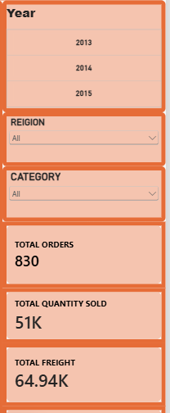
Figure: Slicer panel
Three slicers were added to the Interactive Sales Dashboard to make it interactive:
- Year (from order date: 2013, 2014 and 2015)
- Region (dropdown, based on customer country)
- Category (dropdown, product category)
These slicers allow users to filter the entire dashboard according to their requirements. For example, a user can select a particular year or region and observe how all the charts and cards change accordingly.

7. Key Findings
- The dataset has 830 orders, 91 customers, 51K units sold and 1.27M in total sales. Freight totals 64.94K, an average of 78.24 per order.
- Beverages and Dairy Products are the two strongest categories; Grains & Cereals is the weakest.
- Orders peak in March and April, drop sharply in May and June, and then recover gradually towards December.
- Margaret Peacock handled the most orders, and the USA, France and Germany have the largest customer bases.

8. Conclusion
The Northwind Interactive Sales Dashboard presents orders, sales, customers and freight in a single, interactive view. KPI cards give a quick summary, the charts support comparison and trend analysis, and the slicers, tooltip and drill-through page let users explore the data in more detail. The dashboard can support decisions on product

